

* Long-term/widespread vasoconstriction can have adverse effects

**#1 - Initiating Event**

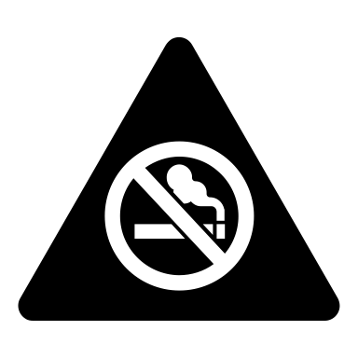

Smoking leads to Alpha-1 Antitrypsin deficiency which causes proteases to go uninhibited and digest tissues

* Chronic Hypoxia leads to Polycythemia (increased RBC production) and Clubbing of Fingers

**#9 – Pulmonary Hypertension**



**Hypertrophy** and **hyperplasia** of the submucosal glands in the large bronchi

**Hyperplasia** of goblet cells in surface epithelium

**#2 – Cellular Adaptation**



Mass vasoconstrictions leads to…

**#10 – Cor Pulmonale**



Long term exposure to an irritant such as cigarette smoke that stresses the tracheobronchial cellular environment

Compensates for decreased ventilation and alveolar hypoxia to divert blood to better-ventilated portions of lungs

* Is adequate for short-term



Chronically hypoxic alveoli



**COPD** = a disease state characterized by persistent airflow limitation that is progressive, not fully reversible, and associated with an abnormal inflammatory response of the lungs to noxious particles or gases

Chronic alveolar hypoxia results in permanent pulmonary hypertension

This pressure increased the stress of the workload of the right ventricle which initiate hypertrophy on the right side of the heart muscles, resulting in eventual heart failure.

Cells adapt in response to stress and injury

* Triggers AIR

**Metaplasia** of ciliated epithelial cells to stratified squamous epithelial cells

Destruction of pulmonary capillary beds



Inadequate ventilation of well-perfused areas of the lungs

Hypoxemia



**#3 – AIR**





Vascular response includes:

1. Vasodialtion
2. Increased CMP
3. Slowed circulation
   1. Results in increased blood flow, and therefore an increased hydrostatic pressure and a decreased intravascular osmotic pressure
   2. Endothelial cells retract (loss of tight junction) which leads to increased CMP which allows for Albumin and H2O to escape
   * This leads to a massive fluid shift from an area of high concentration to an area of low concentration
   1. Decreased plasma in the vessel will increase blood viscosity resulting in the neutrophils to marginate along capillary wall

Impaired ventilation/perfusion (v/Q) ratio

Blood passing through pulmonary capillaries is exposed to less O2



Polycythemia increases oxygen carrying capacity (cellular adaptation example)



* Activated by cell injury
* Is the same in all cases regardless of mechanism of injury
* Has 3 purposes:
  + Neutralize/Destroy
  + Limit spread
  + Pave way for wound healing

Hypercapnia

Decreased Ventilation

**#6 – Airflow Limitations**

* **The key physiologic feature of COPD**

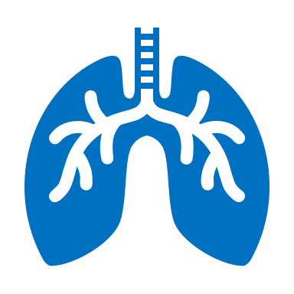

Riley Martian

T00616119

09/29/2019

**#4 – Mucus Hypersecretion**



Decreased recoil results in decreased interalveolar pressure with impacts the process of exhalation

This contributes to air trapping and hyperinflation of the lung

* Irreversible = AIR becomes CIR which leads to airway fibrosis (scarring) and thickened bronchial tissues which is due to cellular adaptation), loss of elastic recoil, and loss of radial traction
* Reversible = Edema of bronchial mucosa (inflammation) and mucus production

Chemical mediators cause bronchoconstriction

Tenacious sputum interferes with the functioning of the mucociliary escalator

Chemical mediators (H & L) initiated in AIR stimulate the hyperplasia of goblet cells in the bronchus

This leads to an increased mucus production

* Tenacious sputum that is difficult to raise

Chronic hypercapnia = increased arterial CO2 which can depress chemoreceptors and lose the stimuli to breathe

The air is trapped within the alveoli (permanent over-inflation) resulting in barrel chest and loss of surface area in contact with the pulmonary vessels

Loss of elastic recoil and radial traction

**#7 – Pulmonary Hyperinflation**



**#8 – Gas Exchange Abnormalities**



Radial traction is lost when the elastic tissue supporting the alveolar ducts and respiratory bronchioles is destroyed and causes them to collapse

The functional tissue of the lungs (parenchyma) involved with gas exchange are destroyed = loss of elastin within the alveolar tissue and therefore lose their ability to recoil

Smoking destroys cilia

Metaplasia of ciliated epithelial cells with stratified squamous epithelial cells impairs the mucociliary escalator

**#5 – Ciliary Dysfunction**



Chemical Mediators:

* Histamine
* Leukotriene
* Prostaglandin
* Bradykinin